Supplemental Figures:
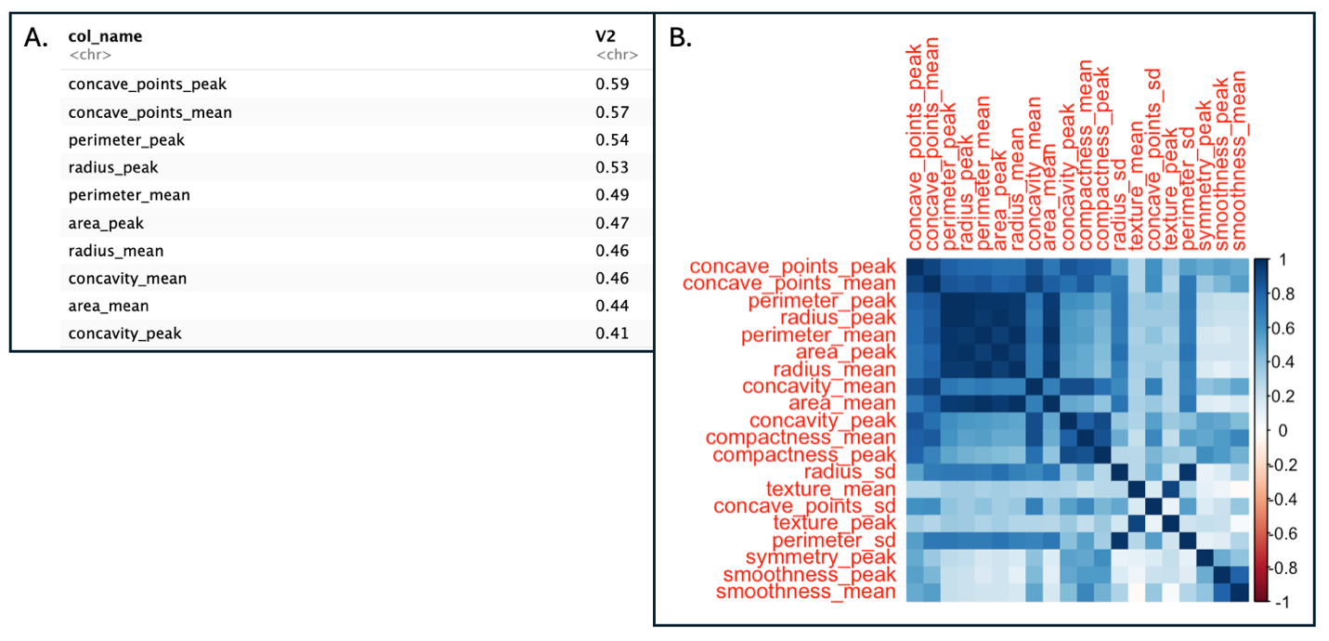
Figure 1. Analysis of variables with highest information gain. A. Table showing the top 10 variables with highest information gain. B. Correlation matrix of variables with highest information gain.

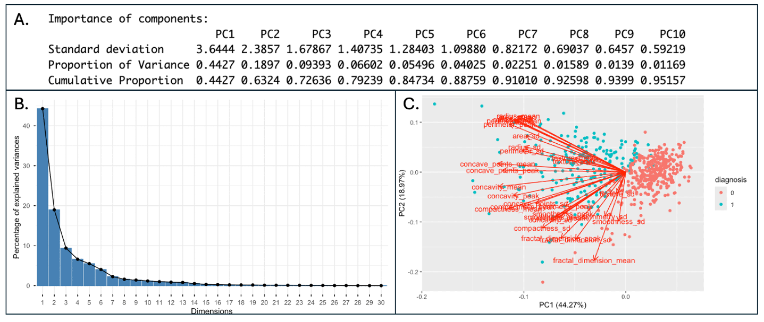
Figure 2. Principal component summary of Wisconsin Breast Cancer Dataset. A. Summary of first 10 PCs which explain a cumulative proportion of 0.951 of the variance. B. Elbow plot of all PCs, showing the decrease in explained variance as dimensions are added. B. Biplot of first two PCs. Line angle and length determine how much a variable contributes to a PC.
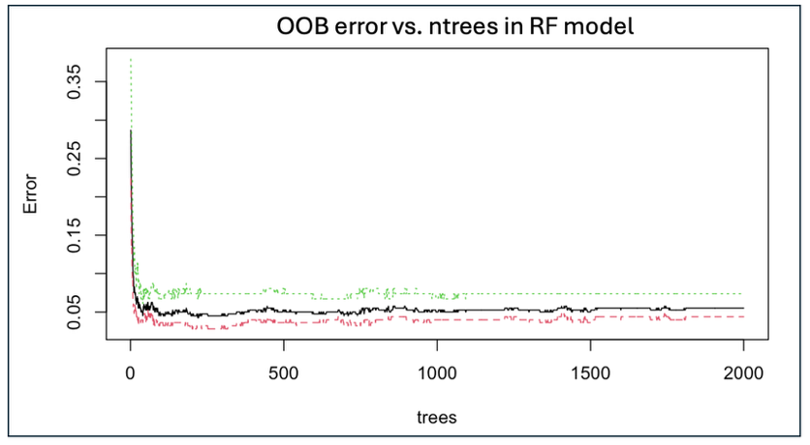
Figure 3. OOB error estimate as additional trees are added to the RF model. Point where OOB stabilizes is desirable, as it minimizes error at lowest computational cost.

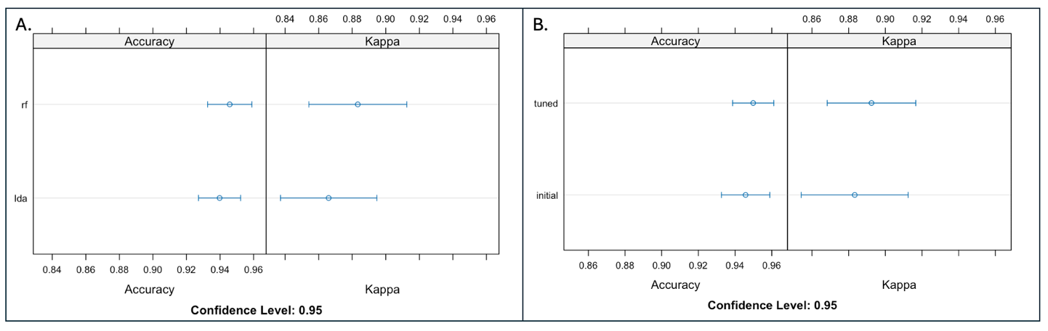
Figure 4. Accuracy and kappa metrics compared across models. A. Initial comparison of RF (top) and LDA (bottom). B. Comparison of tuned (top) and initial (bottom) RF models.

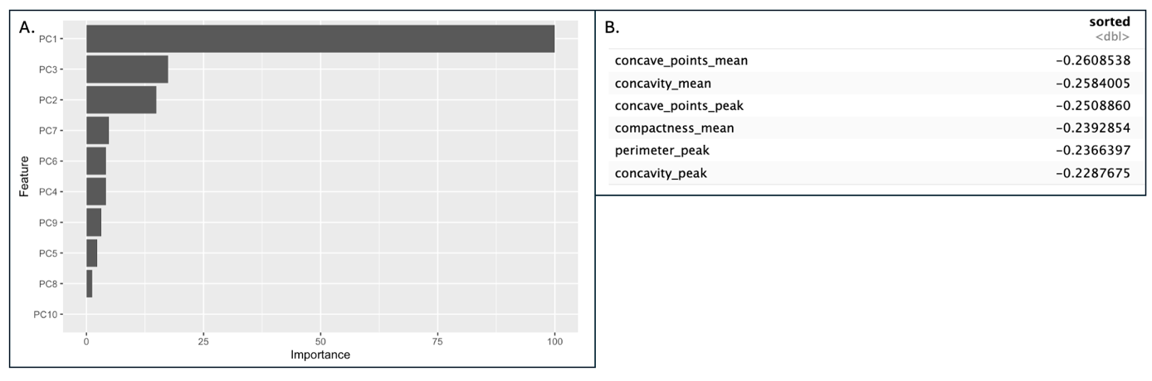
Figure 5. Analysis of feature importance and PCA loadings. A. PCs 1-10 ranked by feature importance in RF model. B. Top 6 loadings of PC1.

